e-books for FE clinic
Wednesday 29th April 2020

Transcript

Slide 1 introduction
Hi everyone and welcome to our e-books for FE April clinic. Thank you for taking the time to join us today, it’s great to see so many of you here. If this is your first time joining us on our webinars, I am Helen, the e-books for FE coordinator and I am joining you today from Wigan, in the North West of England. It’s been a few weeks now that we have all been working from home, and we are sure that you are all settling into working from home and supporting students virtually. So, we are going to move away slightly from our COVID-19 support webinars and this week’s webinar will focus more on e-books again; however we do still have some new resources to share at the end of the session, and we will also have the opportunity for you to share what’s working well with colleagues at the end of the session, as this has become a really important and useful part of these sessions.
As always, the webinar will be recorded, and all links will be sent out to the JiscMail list as soon as they are available.

Slide 2 outcomes
So, the outcomes of the session are to consider how to make the most of using e-books from home. this session will be especially useful for teaching practitioners or librarians who are new to e-books; for many of you here I am sure you are already doing a lot of the things in this session, but I hope you will find some value in attending.
We will also be giving an overview of our new service, Virtual Library, and we will have the opportunity to ask Q&A followed by an opportunity to share best practice.

Slide 3 benefits of using e-books
I know many of you here all expert in the many benefits of using e-books by now, but for the benefit of colleagues who are new to using e-books, we’ll start by taking a look at some of the benefits of using the digital versions of books. There really is no better time to get to grips with e-books, and I think e-books are really showing their worth during this time. Some of the key benefits of using e-books include:
- They can be read online simply by logging in using college credentials. All learners need to access them is a device and their college login details
- Learners can also download key chapters for offline use, and also for use with assistive technologies for accessibility purposes
- More accessible than their print equivalents - text can be re-sized and many ebooks are compatible with screen readers.
- Learners can easily search within the text for keyword/s making it easy to find the information that they are looking for, so there’s no need to waste time trawling through a traditional index
- They can be accessed from mobile devices including tablets and smartphones so again are ideal for studying from home, where not all learners have access to computers or laptops
- They can’t be lost or stolen! I know when I was a school librarian, long period of school closure lent themselves a little too well to books going missing or being destroyed by younger siblings. With e-books you can be safe in the knowledge that there will be no financial loss due to lost or damaged books
- Learners don’t borrow the books as they would a traditional library book, meaning there are no fines for overdue books

Slide 4 unlimited access

Unlimited access means that learners don’t need to wait until someone else has finished with the book and don’t have to join a long reserve list. This feature lends itself well to collaborating with peers whilst learning from home. Learners could set up sessions with classmates to discuss different chapters of books, work together on the practice questions. This would add structure to group work students and ensure learners are still benefiting from discussions with peers, which are essential for consolidating knowledge and understanding, as well as ensuring socialisation.
If there are titles that aren’t covered by e-books for FE but that your learners need, you can purchase titles from ProQuest for your organisation. ProQuest are upgrading all licences purchased during COVID-19 to unlimited licences until the end of June:
https://www.proquest.com/blog/pqblog/2020/Coronavirus-Impacted-Libraries-Get-Unlimited-Access-to-Ebook-Central.html
https://media2.proquest.com/documents/unlimited-access-ebookholdings.pdf
https://www.proquest.com/blog/pqblog/2020/ProQuests-E-Now-Enables-Libraries-to-Meet-Unprecedented-Demand.html

Slide 5 download chapters and titles

Learners can download the e-books or key chapters to their device so that they can access them anywhere, anytime, offline. This is especially useful for learning from home and the inevitable internet failures. Students could download relevant titles to their courses to their device, so that if their internet does go down, they have something they can fall back on.
- Learners can see how much of the book they are able to copy and download by clicking on the book details. This will be different for each learner, as users have a given allocation for each unique title. When they have used this up, they are no longer able to copy and download from this title
- https://support.ebooksforfe.jisc.ac.uk/index.php/librarian-support/proquest-ebook-central-support/downloading-e-books/

Slide 6 example of download chapters and titles

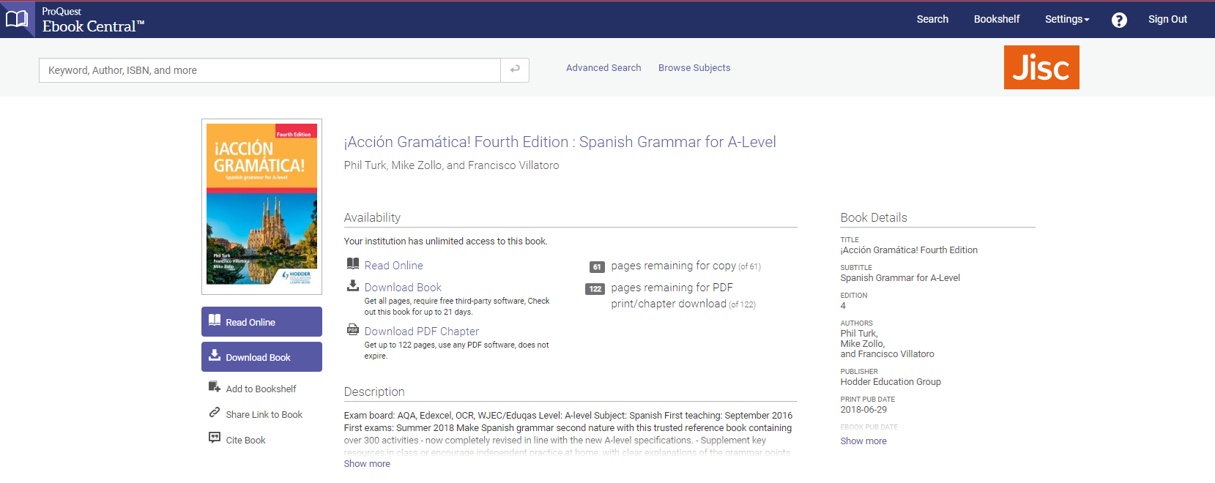

Slide 7 engagement through annotations
Learners can engage deeply with the books through annotations, just like they would in a print book. Learners can highlight key sentences and paragraphs, can bookmark useful chapters and can add their one notes to the books.
- Annotation Pane- this contains all highlights, notes and bookmarks in a book, arranged by page and type.
- Highlights – learners can select text on a page and choose to highlight in yellow, blue or pink from the pop-up menu.
- Highlights – Toolbar - Use the highlight icon in the toolbar to highlight text in yellow.
- Add Note – learners can create a note by selecting text on a page and choosing the note icon in the pop-up menu. Saving the note will save this for them when they return to the book. they can also adda note to the whole page rather than selected text
- Bookmarks - learners bookmark a page for future reference
- Export Notes from Bookshelf - Notes can be exported from the bookshelf. Find the book in your bookshelf, select the More icon and click on Export Notes.
For more information on the functionality available with annotations:
https://proquest.libguides.com/ebookcentral/annotations

Slide 8 example of engagement through annotations

Slide 9 Bookshelf

Bookshelf
The bookshelf in ProQuest Ebook Central keeps track of users’ downloads, loans and saved books, and lets you share them with others.
Features include:
1.Download & Loans
Easy access to the books you’ve downloaded or have on loan, and a reminder of how many days are remaining.
2. Recently Viewed
Up to 10 titles that you’ve recently viewed are displayed here.
3. Annotated Books
Easy access to all of the books that you have bookmarked, highlighted or added notes to
4. Save to Bookshelf
Organize your books into as many folders as you’d like. Your bookshelf comes with a Research folder and you can add more folders as you need them.
7. Share Link to Folder
Share a link to your folder with others at your organisation. The link could be used to create online course reading lists or new title lists for teachers and departments
8. Email Folder
Email folder contents to other Ebook Central users.
9. Export Folder
Export folder contents in spreadsheet format with URLs to all titles
11. Export Notes, Share Link to Book, Copy To, Remove
Export your notes and bookmarks; share a link to the book; copy a book to another folder; or remove the book from your bookshelf.
12. Citation support
Create a citation from your choice of the most frequently used styles: APA, Chicago/Turabian - Notes-Bibliography, Chicago/Turabian - Author-Date, Harvard, MLA, or Vancouver.
This function is especially useful during COVID-19 closures, as teachers and librarians can easily create shareable bookshelves to direct students to useful titles. For example, you could create a bookshelf with titles specific to each subject area
- Email the link to subject teachers
- Export Bookshelf which instantly converts the Bookshelf into a handy spreadsheet with links to the e-books in the shelf

Slide 10 Bookshelf
To create bookshelves, simply click on bookshelf in the top right corner of Ebook Central. To create a new folder simply click new folder

Slide 11 Bookshelf
Add a title to your Bookshelf, and this will add it to your list of Bookshelves on the left here.

Slide 12 add to Bookshelf
To add a book to your Bookshelf, simply search the ISBN of the book you want, and click add to Bookshelf underneath the download icon. You will then be promoted to select a bookshelf to add the title to.

Slide 13 export Bookshelf as a csv spreadsheet
This slide demonstrates how you are able to export the Bookshelf as a csv spreadsheet that contains handy URL links to the titles, which is again really useful for sharing with teaching practitioners.

Slide 14 Workbooks and practice books
These titles are especially useful as they contain ready-made practice questions for learners. They are especially useful for teachers with limited time to prepare materials for home study. All workbook titles are listed on this slide, and I will send this list as a spreadsheet with the follow-up materials for the session.
Cover the following subject areas:
- Animal care
- Arts
- Digital and IT
- English
- Hair and beauty
- Mathematics
- Media
- Politics, economics and law
- Social sciences

Slide 15 embed links into your VLE

A great way to promote the visibility of e-books is to include links to e-books in your virtual learning environment (VLE) in individual subject pages.

All e-books can be easily inserted as links into your VLE so that learners can easily locate them with the click of a button. If you are unsure about how to do this, do get in touch with us and we can show you how to do this.

Slide 16 Webinars from ProQuest
ProQuest have set up some brilliant webinars on LibCentral throughout May. Each webinar will cover the same content, so you only need to register for 1. The webinars will give an overview of the administrative site LibCentral, and the content will include running usage reports and downloading MARC records. To register, simply select the date and time that is most convenient and register using the link on the screen.

Slide 17 Virtual Library

We will move on to our next segment, which is Virtual Library, our new service which was designed as an enhancement to e-books for FE.

Slide 18 Virtual Library – overview
You may have seen our email earlier this week, and I know many colleges have already signed up for this brand new service which will be available to install from Friday. Virtual Library is a place where you can find all of Jisc’s resources for FE, and can be integrated with your college’s existing VLE via learning tools integration technology.
By uniting all of our resources into a single tool which can be fully integrated with your college’s existing online platform, we’ve streamlined the experience of getting resources in front of your learners. Virtual Library includes the full e-books for FE catalogue, and links to all of Jisc’s Vocational Learning Resources, making it easier than ever for you to find relevant Jisc resources. The resources are organised by subject area, and every e-book and resource contains descriptions and images, turning both browsing and finding what you need quickly into a visually appealing experience.
Virtual Library will be updated every year to coincide with Jisc’s e-books for FE refresh, so you can be sure your students are getting access to the most up-to-date resources Jisc has to offer. The updates will be entirely handled by Jisc, and updates will be applied instantaneously so you don’t need to worry about manually updating.
As Virtual Library is built into Moodle, you’ll be able to reap the benefits of Moodle’s tracking abilities, so you’ll be able to get an idea of student usage of the resource. If your college uses Moodle as it’s LMS, this information will come to you automatically.

Slide 19 Virtual Library – content
Jisc Virtual Library includes: - The full e-books for FE catalogue, sorted by subject area, updated every year
- Links to Jisc’s Vocational Learning Resources for Construction, Engineering, ICT and Childcare and Education, which are priced according to Jisc banding (these are currently free for ALL our members until 31st July to help learning from home
- Links to additional resources from Jisc Collections, specially curated to be relevant to FE institutions
- A handy on-board guide for making the most of the Virtual Library
- An area dedicated to GCSE English and Mathematics

Slide 20 Virtual Library – how to subscribe
It’s easy to subscribe for Virtual Library from Jisc’s Licence subscriptions manager (LSM). Simply login to the LSM and subscribe using the link here.
- https://subscriptionsmanager.jisc.ac.uk/catalogue/2398
If you don’t know your username and password to access the LSM, please email help.digitalresources@jisc.ac.uk with the subject ‘LSM login details’ to request your login details

Slide 21 our Q&A
Before we go into our usual Q&A, we have two questions that we would like to ask you. Please type your feedback into the chat panel for us to collate and pass on to the team.
Q: If there was a centrally hosted place for curriculum mapped FES learning resources, would this be of interest to you?
Q: What content would you like on this central platform?

Slide 22 your Q&A
Q&A.

Slide 23
Share best practice

Slide 24
Here are some further links that you might find useful

Slide 25
Share best practice

