|  |  |
| --- | --- |
|  | **e-books for FE**  Usage reports for Jisc e-books and purchased content in LibCentral  **Support contact:** [content.feandskills@jisc.ac.uk](mailto:content.feandskills@jisc.ac.uk) |

To run usage reports for Jisc e-books or your own purchased ProQuest content, log in to your own college instance of LibCentral at this URL, with your ProQuest site ID in place of the red text:

[**https://**](https://brooklands-ebooks.ebookcentral.proquest.com/libcentral)**yourProQuestsiteID.ebookcentral.proquest.com/libcentral**

If you don’t know what your ProQuest site ID is,

* Log in to ProQuest Ebook Central: <https://ebooksforfe.jisc.ac.uk>
* Look at the URL in your internet browser's address bar
* Your site code can be found between lib/*********/home

For example:

https://ebookcentral.proquest.com/lib/**smithcollege-ebooks**/home

If you don’t know what your institutional log-in details are for LibCentral, contact [ebooksupport@proquest.com](mailto:ebooksupport@proquest.com) with your ProQuest site ID in the Subject line and ask them for the username and password – they may have already been given to a staff member in the past, and if that staff member has left you may require a new one.

Once logged in to your LibCentral platform, the **LibCentral Dashboard** on the left hand side will show what e-books you have access to:

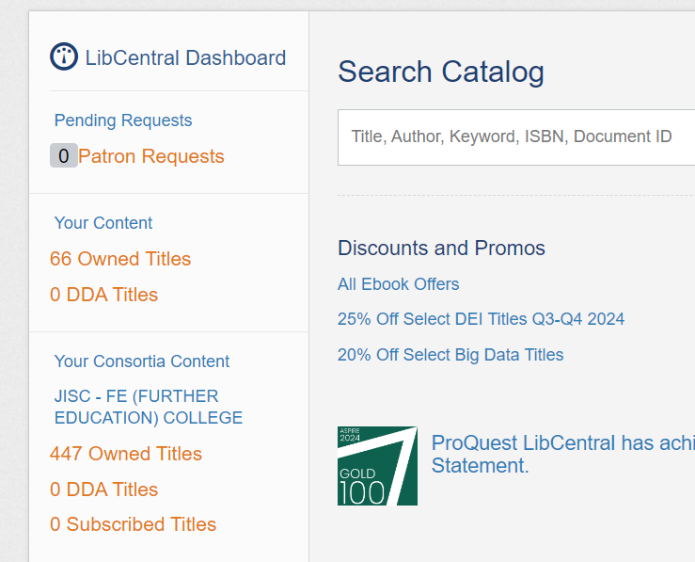

* **Your Content** = e-books you have **purchased** from ProQuest (if you have any)
  + You can run ProQuest Usage reports and Title reports and COUNTER reports
* **Your Consortia Content** = the Jisc e-books for FE collection
  + You can run COUNTER reports only

To generate COUNTER usage reports for Jisc e-books or your own purchased titles:

In the top toolbar go to **Reports** > **COUNTER Reports**

In the ‘**Create COUNTER Reports**’ options, there are three options available:

* **All Content (Member + Consortia)** = titles you have purchased *plus* Jisc e-books together
* **Purchased Content** = only titles you have purchased
* **Purchased Content (jiscfe-ebooks)** = only Jisc e-books for FE

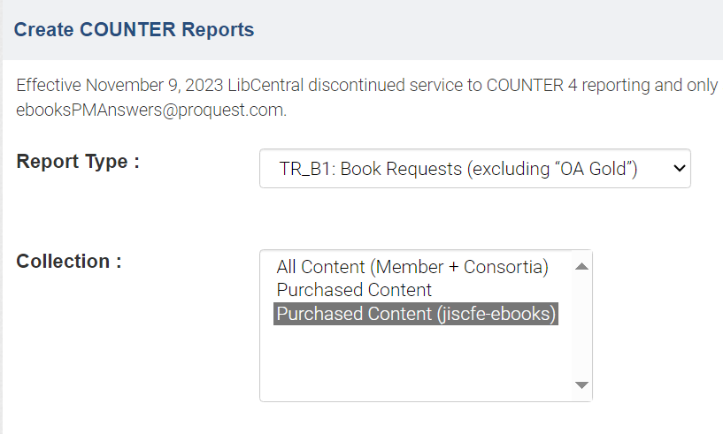

Recommendation:

* Use the **TR_B1: Book Requests** report

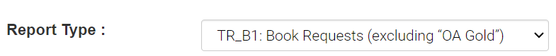

COUNTER report terminology

A **request** = an action which includes

* Accessing the e-book via the online reader
* Downloading a chapter
* Downloading a whole e-book
* Copying content
* Printing content (i.e. saving to PDF)

In the **TR_B1: Book Requests** report:

* **Total_Item_Requests** = total number of e-book reader sessions and/or chapter downloads and/or e-book downloads and/or copy actions and/or print to PDF actions
* **Unique_Title_Requests** = total number of unique **user sessions** which have generated the item requests for that title

The Unique_Title_Requests are the closest metric to the ProQuest **user sessions**, i.e. the usage numbers distributed by the Jisc team, but they are not a 100% match.

The ProQuest-style usage reports for Jisc e-books will be circulated via the e-books for FE JiscMail list **every month** and **every quarter**. If you would like a ProQuest-style usage report for your college outside of these reporting periods, please contact [content.feandskills@jisc.ac.uk](mailto:content.feandskills@jisc.ac.uk)

**How-to video guides**

For an explanation of the various COUNTER metrics available, and e-book reporting in general, there is a 50-minute ProQuest webinar recording here:

<https://share.vidyard.com/watch/vJ7Sb1U4HEVxAxvAnYVPtV>